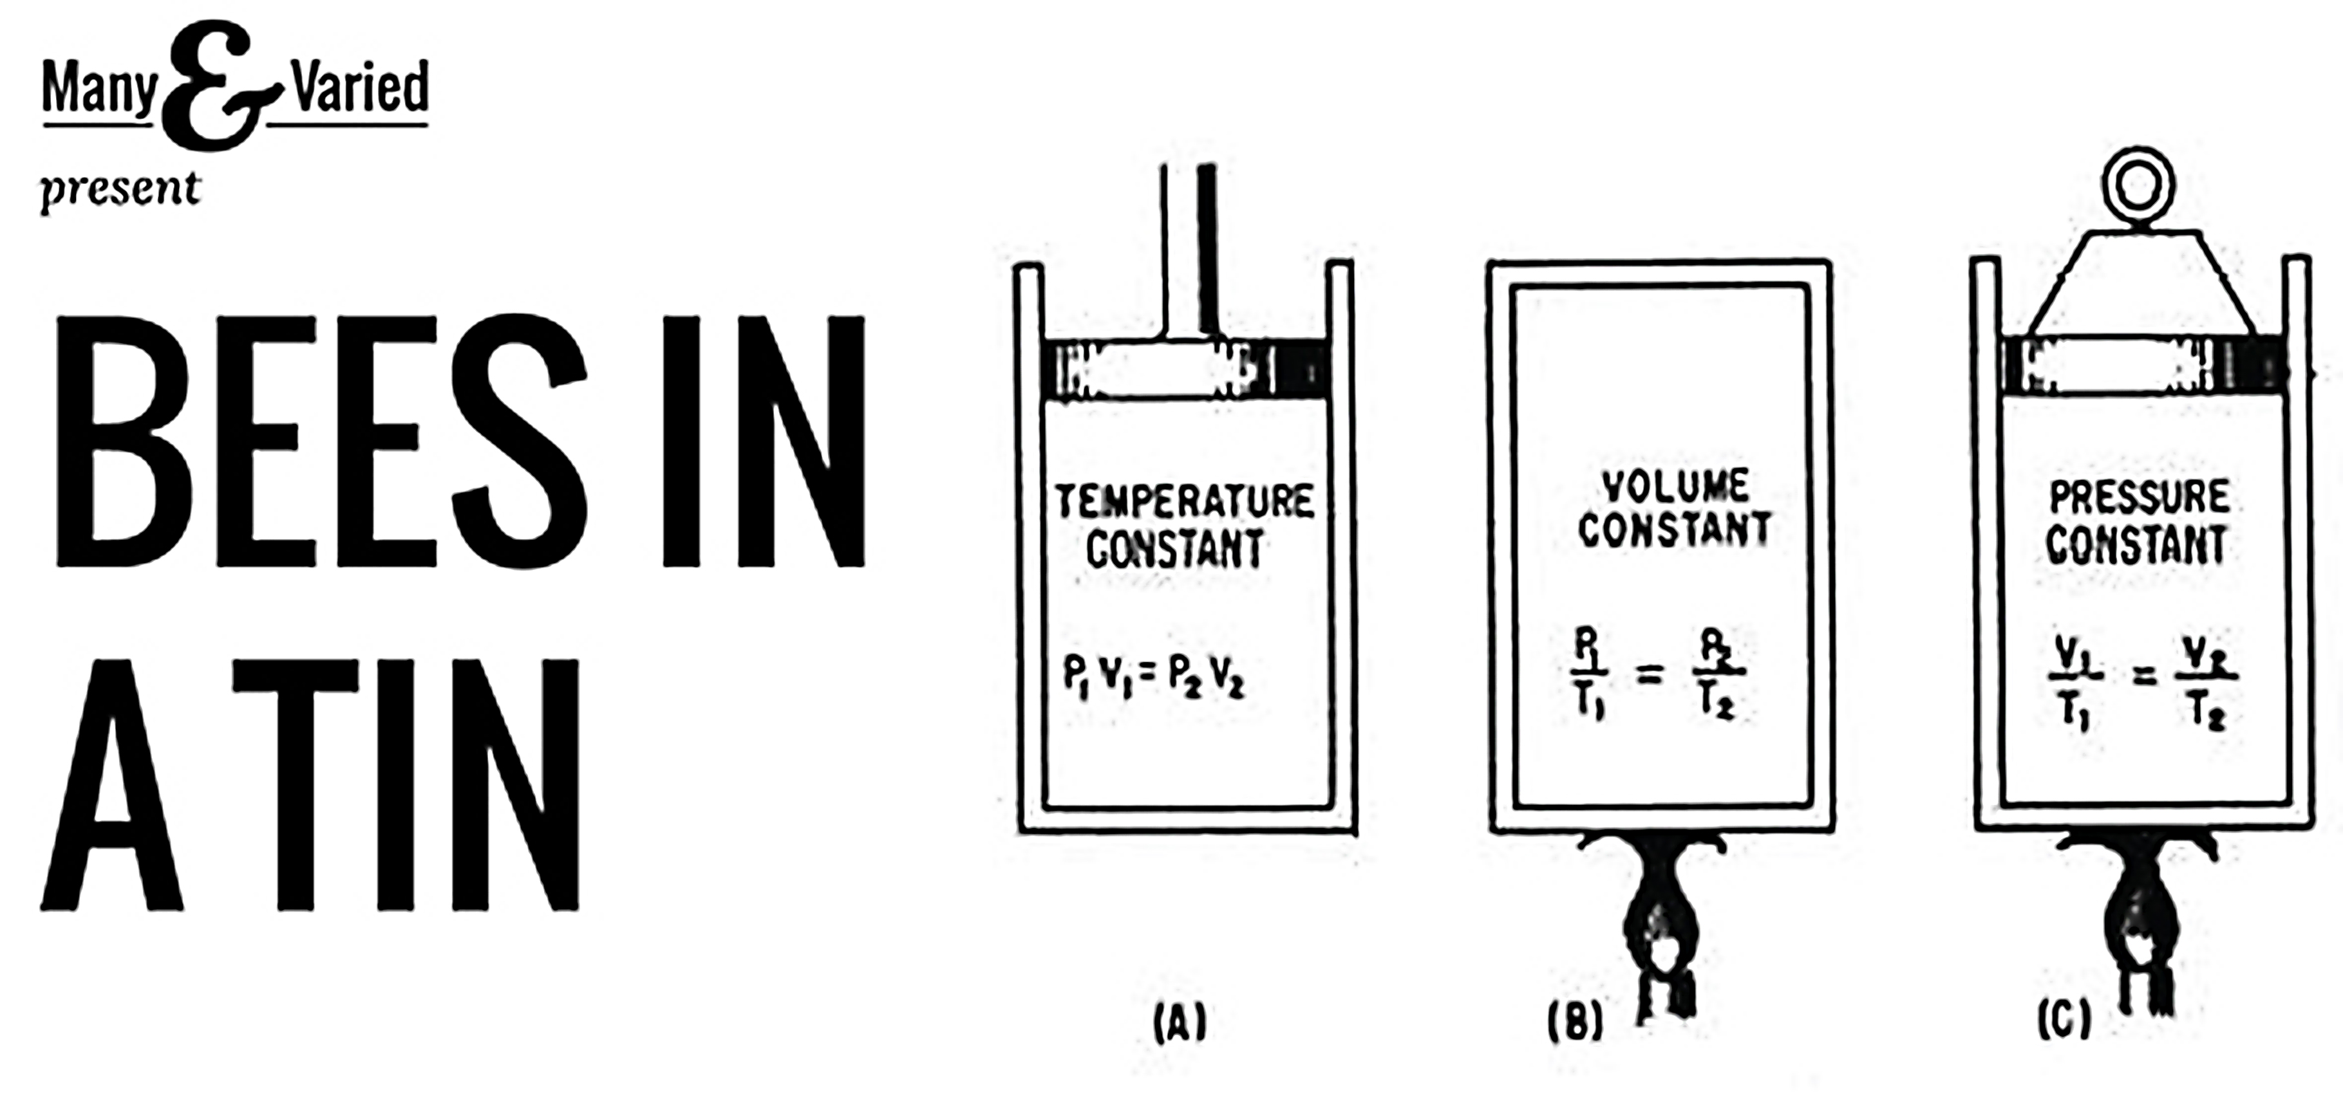
Many & Varied in partnership with Supersonic present
Bees in a Tin 2015
12th June, 2015 • Birmingham

Expression of Interest

CALL FOR EXCITING and INTERESTING THINGS! Do you do exciting and (or) interesting things? Then this is for you!

Bees in a Tin is a gathering happening on Friday the 12th of June 2015 for interesting and exciting people who make unique interfaces for the world around them. And we’re currently looking for people to present… interesting and exciting things, experiences, performances, talks, artefacts, ideas and other nouns, at the event.

If you have devised (or are devising) a novel way of interacting with your surroundings that makes people stop, think or just go “wow!”, then we would like to be in the same room as you. Your project could be a performance piece; guided walk; interactive object; data visualisation; science experiment or something completely different. Surprise us!

Please ensure you have read all the supporting information at http://manyandvaried.org.uk/bees_2015_call/ before completing and returning this form.

If you have any queries, please email bees2015@manyandvaried.org.uk

Your Name:
Contact email address:
URL of your website (if applicable):
An introduction to yourself (200 words max):
An overview of your project (200 words max):
What you would like to do at the Bees in a Tin event (200 words max):
Last year we had presentation slots of 15 minutes and workshop slots of 30-90 minutes that worked well, but tell us what you have in mind.
A brief list of any facilitation you would need from us in order to be able to do this (length of time slot, arrangement of furniture, number of participants etc.):

Details of additional links or attachments to illustrate your project (no more than 3, please ensure total size is less than 3MB):

Please let us know if you have individual requirements (dietary, mobility, communication etc) you'd appreciate support with. Not part of the selection process, but means we can get a headstart on doing what we can to help make the event work for you.

Key dates:
Deadline for submissions: 5pm, 29th April, 2015
Notification of successful proposals: 8th May, 2015
Event date: 12 June, 2015

Event location:
Thinktank at Millennium Point, Curzon Street, Birmingham, West Midlands B4 7XG
http://www.millenniumpoint.org.uk/visit-us/

Sending us your expression of interest:
Please complete this form and rename the file with your first and surnames at the beginning of the filename. For example: 'Nikki Pugh – Bees in a Tin 2015 - EOI'

Email this form and any supporting images (less than 3MB total size) to bees2015@manyandvaried.org.uk

Support:
Bees in a Tin is supported using public funding by the National Lottery through Arts Council England. Presented in partnership with Supersonic. Also supported by Creative Enterprise at Coventry University and Birmingham City University. Hosted by Thinktank and Millennium Point.



